Archive Manifest

# Revision

Version 2

1/27/22 8:18 AM

# SME

Charles Wilson

# Abstract

This document describes the process to create a manifest of archived elements needed to reproduce the product.

# Group / Owner

DevOps / Information Systems Security Developer

# Motivation

This document is motivated by the need to have formal processes in place tracking the tools used and products generated in creation of safety-critical, cyber-physical systems for certification of compliance to standards such as **ISO 21434** and **ISO 26262**.

# License

This work was created by **Motional** and is licensed under the **Creative Commons Attribution-Share Alike (CC BY-SA-4.0)** License.

[**https://creativecommons.org/licenses/by/4.0/legalcode**](https://creativecommons.org/licenses/by/4.0/legalcode)

# Overview

It is critical that all elements and information necessary to regenerate a product are archived and that a manifest of these materials is created. This serves to ensure that the product release can be updated should the need arise and provides a mechanism to allow for the quick determination of vulnerability for any of the elements used in the product’s creation.

The following diagram shows the workflow to be used.

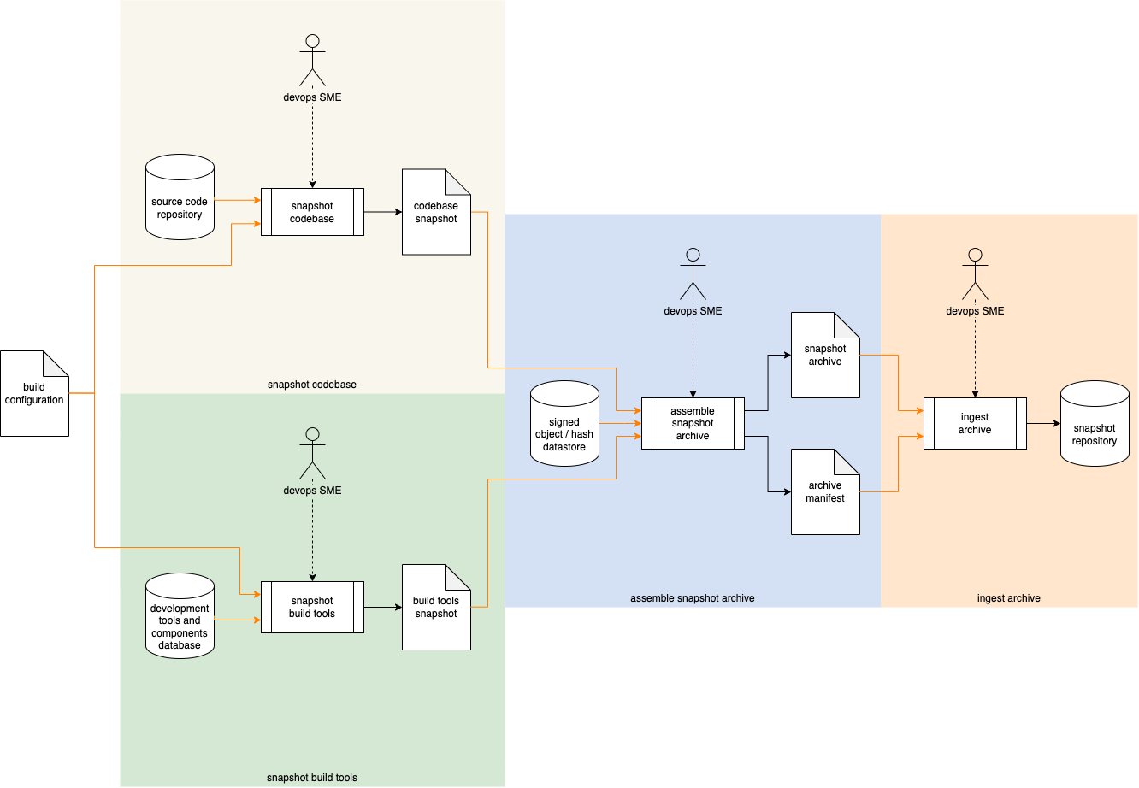

# Process

## Snapshot Codebase

|  |  |
| --- | --- |
| Inputs | Source code repository  Build configuration |
| Outputs | Codebase snapshot |
| Participants | None |

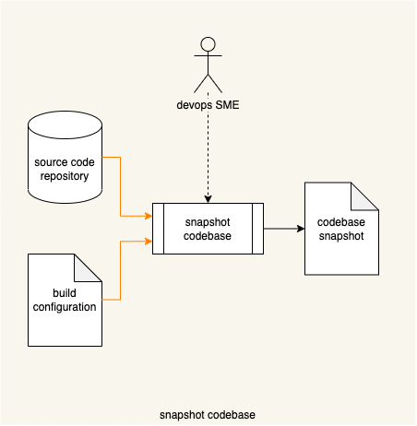

Using the **build configuration**, the **source code repository** is accessed to generate a **codebase snapshot**.

**Note:** Depending on the implementation, this activity may be performed either by a devops SME or via automation.

**Note:** The conformation (full repo vs. tip) of the snapshot is the responsibility of the organization.

**Note:** The codebase snapshot is understood to include associated data (such as configuration files).

**Note:** The snapshot may take the form of an actual copy of the code used to produce the build or permalinks to the same.

## Snapshot Build Tools

|  |  |
| --- | --- |
| Inputs | Development tools and components database  Build configuration |
| Outputs | Build tools snapshot |
| Participants | None |

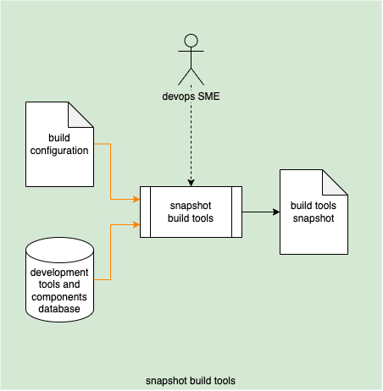

Using the **build configuration**, the **development tools and components database** (established in **List of Approved Tools** **[1]**) is accessed to generate a **build tools snapshot**.

**Note:** Depending on the implementation, this activity may be performed either by a devops SME or via automation.

**Note:** The snapshot may take the form of an actual copy of the tools used to produce the build or permalinks to the same.

## Assemble Snapshot Archive

|  |  |
| --- | --- |
| Inputs | Codebase snapshot  Build tools snapshot |
| Outputs | Snapshot archive  Archive manifest |
| Participants | None |

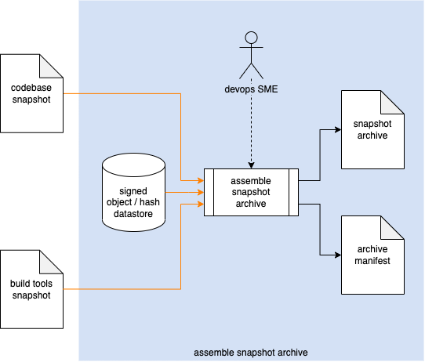

The **codebase snapshot**, **build tools snapshot**, along with the corresponding build product (extracted from the **signed object / hash datastore [2]**) are consolidated into a single **snapshot archive**. An **archive manifest** is generated.

**Note:** Depending on the implementation, this activity may be performed either by a devops SME or via automation.

## Ingest Archive

|  |  |
| --- | --- |
| Inputs | Snapshot archive  Archive manifest |
| Outputs | Snapshot repository |
| Participants | None |

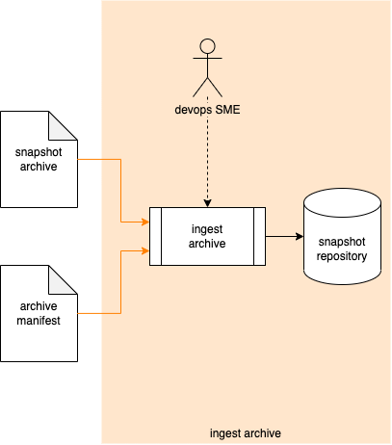

The **snapshot archive** and **archive manifest** are associated and stored in the **snapshot repository**.

**Note:** Depending on the implementation, this activity may be performed either by a devops SME or via automation.

# References

1. **List of Approved Tools** (AVCDL secondary document)
2. **Release Integrity Plan** (AVCDL secondary document)
3. The Case for Software Bill of Materials [video 37m] <http://video.sonatype.com/watch/k1q2hYfAussHmetReM3Jbm>
4. ISO 19770-2:2015 **Information technology - IT asset management - Part 2: Software identification tag**<https://www.iso.org/standard/65666.html>
5. NIST IR 8060 **Guidelines for the Creation of Interoperable Software Identification (SWID) Tags**  
   <https://nvlpubs.nist.gov/nistpubs/ir/2016/NIST.IR.8060.pdf>